Step 1: Go to https://login.newrelic.com/login and create an account

Step 2: To monitor a new Server/Laptop, click on Servers

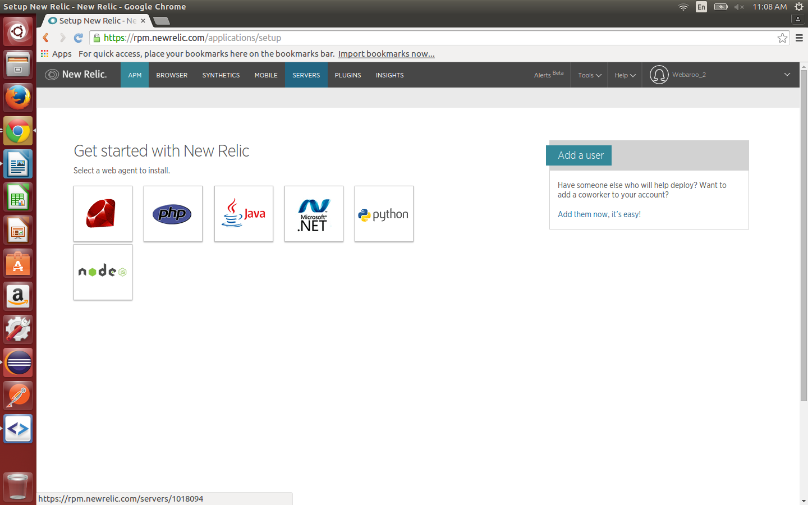
Step 3: Follow the instructions and your laptop will start sending data to new relic.

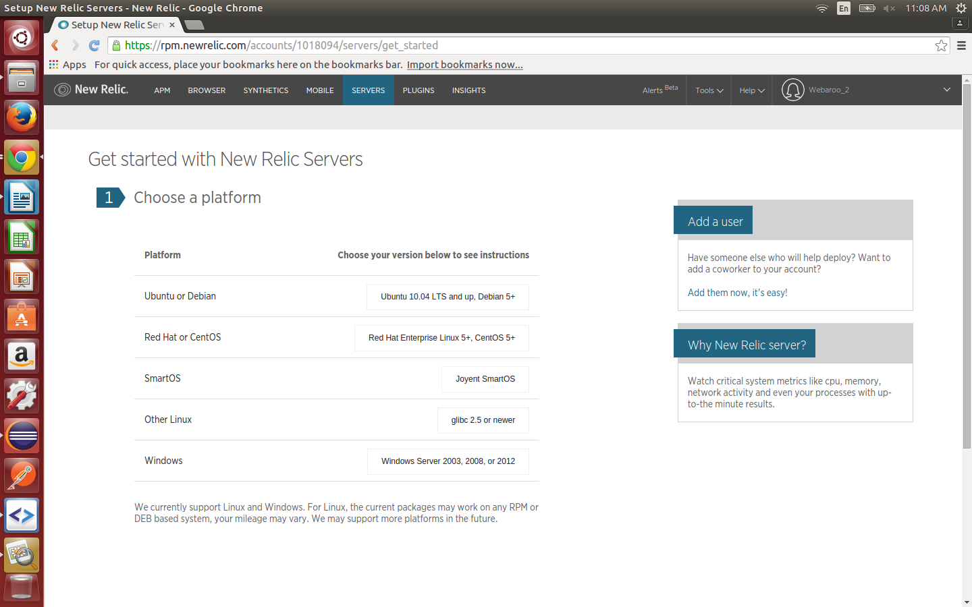

Step 4: Go to account settings->alerting notifications->webhook. This is the place where you test & enter your webhook url

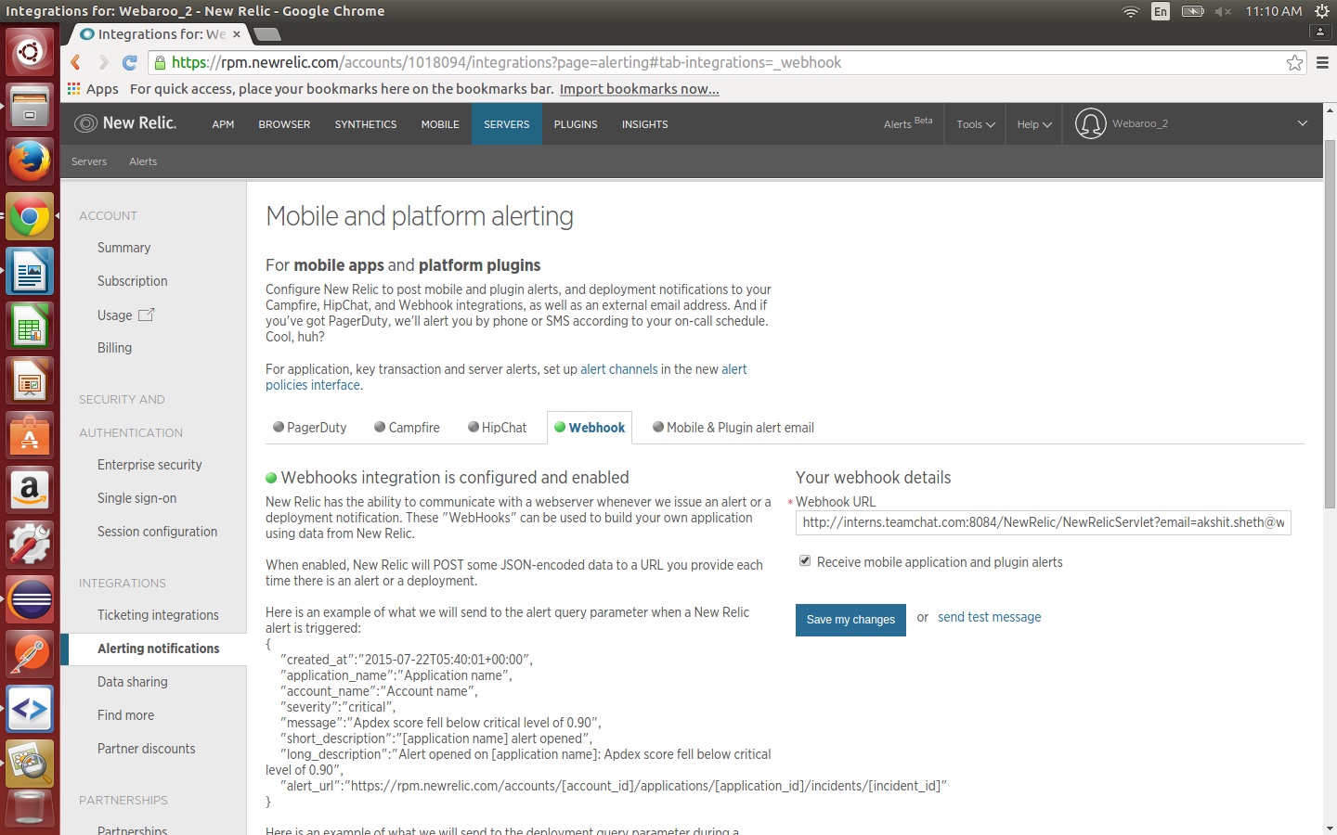
Step 5: On the same screen, click on alert policies interface. Go to Server policies & edit the default alert policy as per requirement.

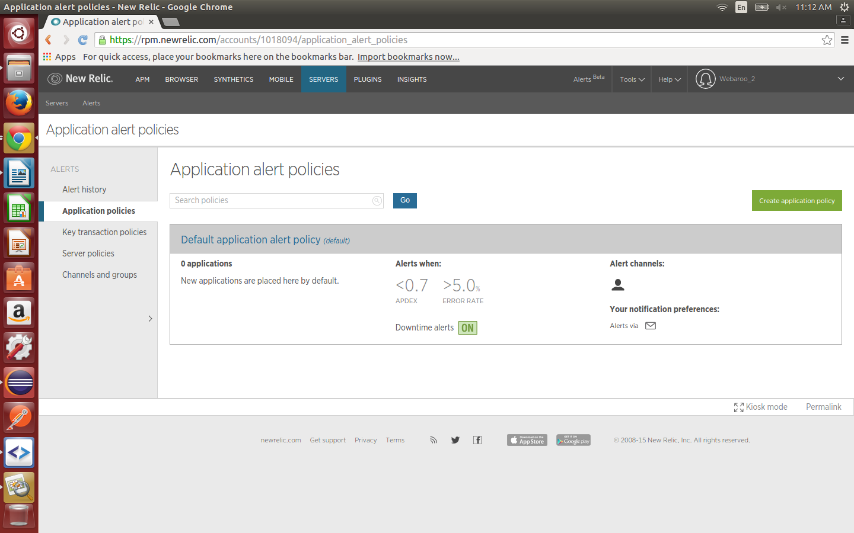

Step 6: Click on Channels & Groups->Create Channel->Webhook. Enter the webhook URL again and save.

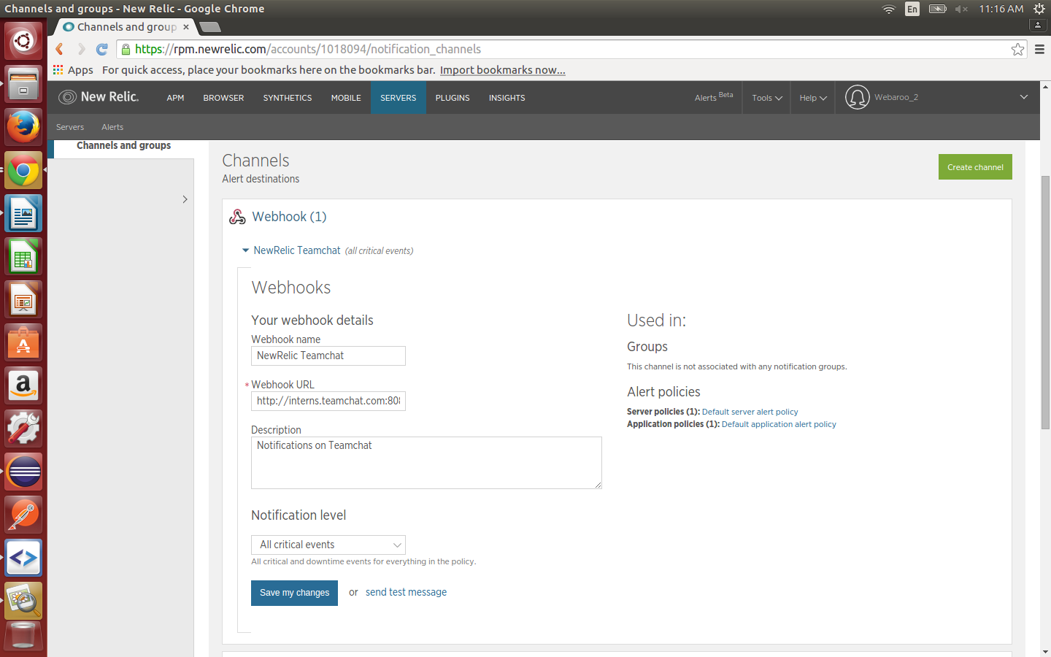
Step 7: On the server policies screen, click on Default Server policy and click on channels. Select the webhook channel you just created for the alert policy.

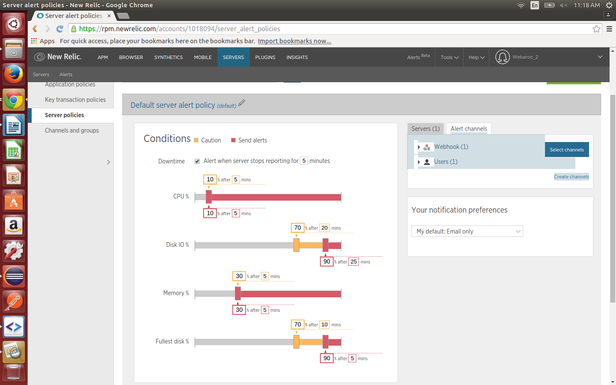
Step 8: You are good to go now. The code doesn't require any Client id or client secret but if you move it to a new server, the webhook url that the bot asks the user to register as his url should be altered along with the port number.

